Nama : Andri Firman Saputra  
NIM : 201011402125  
Kelas : 02TPLP023  
Tugas : Algoritma II – Pertemuan 12

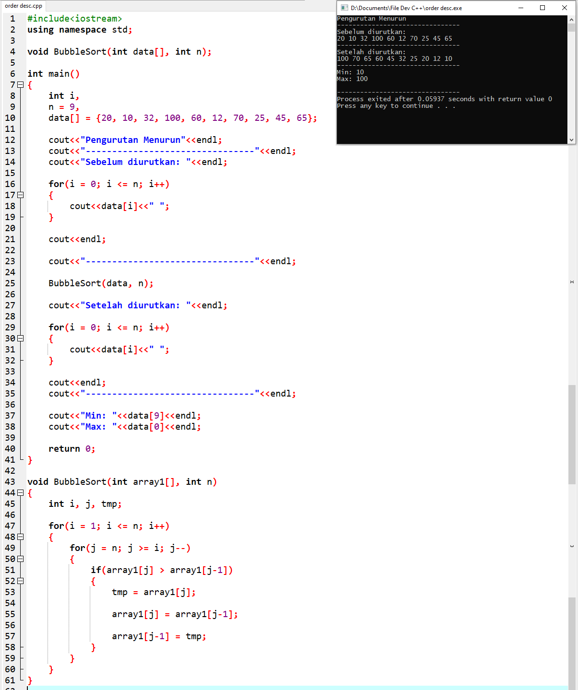

**Source Code:**

#include<iostream>

using namespace std;

void BubbleSort(int data[], int n);

int main()

{

int i,

n = 9,

data[] = {20, 10, 32, 100, 60, 12, 70, 25, 45, 65};

cout<<"Pengurutan Menurun"<<endl;

cout<<"--------------------------------"<<endl;

cout<<"Sebelum diurutkan: "<<endl;

for(i = 0; i <= n; i++)

{

cout<<data[i]<<" ";

}

cout<<endl;

cout<<"--------------------------------"<<endl;

BubbleSort(data, n);

cout<<"Setelah diurutkan: "<<endl;

for(i = 0; i <= n; i++)

{

cout<<data[i]<<" ";

}

cout<<endl;

cout<<"--------------------------------"<<endl;

cout<<"Min: "<<data[9]<<endl;

cout<<"Max: "<<data[0]<<endl;

return 0;

}

void BubbleSort(int array1[], int n)

{

int i, j, tmp;

for(i = 1; i <= n; i++)

{

for(j = n; j >= i; j--)

{

if(array1[j] > array1[j-1])

{

tmp = array1[j];

array1[j] = array1[j-1];

array1[j-1] = tmp;

}

}

}

}

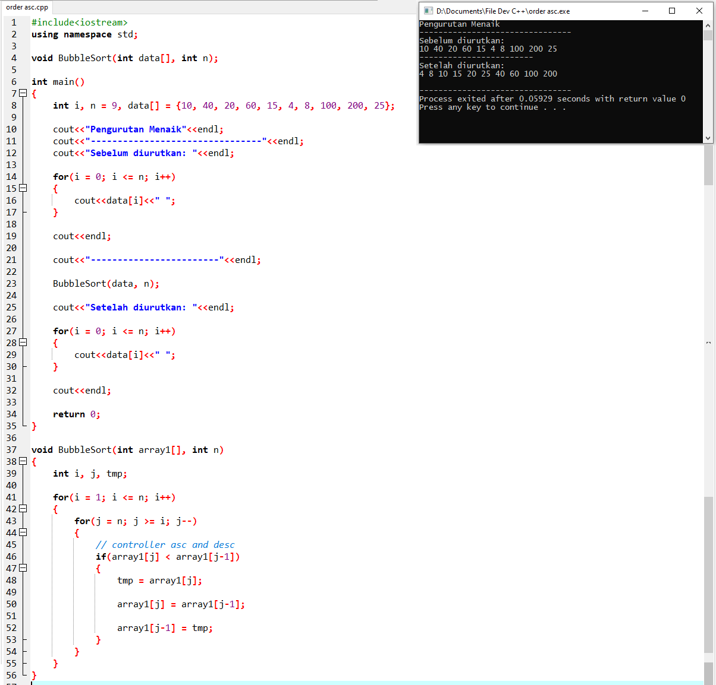

**Source Code:**

#include<iostream>

using namespace std;

void BubbleSort(int data[], int n);

int main()

{

int i, n = 9, data[] = {10, 40, 20, 60, 15, 4, 8, 100, 200, 25};

cout<<"Pengurutan Menaik"<<endl;

cout<<"--------------------------------"<<endl;

cout<<"Sebelum diurutkan: "<<endl;

for(i = 0; i <= n; i++)

{

cout<<data[i]<<" ";

}

cout<<endl;

cout<<"------------------------"<<endl;

BubbleSort(data, n);

cout<<"Setelah diurutkan: "<<endl;

for(i = 0; i <= n; i++)

{

cout<<data[i]<<" ";

}

cout<<endl;

return 0;

}

void BubbleSort(int array1[], int n)

{

int i, j, tmp;

for(i = 1; i <= n; i++)

{

for(j = n; j >= i; j--)

{

// controller asc and desc

if(array1[j] < array1[j-1])

{

tmp = array1[j];

array1[j] = array1[j-1];

array1[j-1] = tmp;

}

}

}

}